An amazing paper for SKI 2023

Author A¹, Author B², Author C³

¹Department Name, Institution/University, authora@email.com
²Department Name, Institution/University, authorb@email.com
³Department Name, Institution/University, authorc@email.com

ABSTRACT: Primary header style (Heading 1)
The purpose of this document is to provide a template for short paper submissions Each section begins with short parenthetical statement that includes the section type (title, author, abstract, Introduction, etc.) as well as the formatting for the text in that section (this should be removed in the submitted version). We suggest the following sections of the short paper: Introduction, Methods & Data, Results, Discussion & Conclusions, Acknowledgments and References.

1. Introduction: Primary header style (Heading 1)
The introduction should include the relevance of the research and the areas of science to which it will contribute and a short literature review. Introduce the research problem and research questions. With the limited space available it is critical that this section is concise and to the point. However, it will be critical that the relevance of the research is clearly stated and well argued.

2. Methods & Data: Primary header style (Heading 1)
The Methods and Data section will outline the research methodology used as well as what data was used and from where it came. With any standardized format such as this there will be instances when the suggested outline of sections are not relevant. In this case, GIScience topics such as non-applied spatial econometrics, geodesy, ontologies, etc. might not have formal methods, per se. In these cases authors should feel free to adapt this template to their needs; however keeping the standard headings and sections where possible will ensure a timely and efficient review and help make the Programs Committee’s work much easier.

2.1 Secondary header style (Heading 2)
It might be helpful to use secondary headings.

2.1.1 Tertiary header style (Heading 3)
It might be helpful to use tertiary headings.

3. Results: Primary header style (Heading 1)
This is the section where your results are reported.
Table 1: Below is a representation….

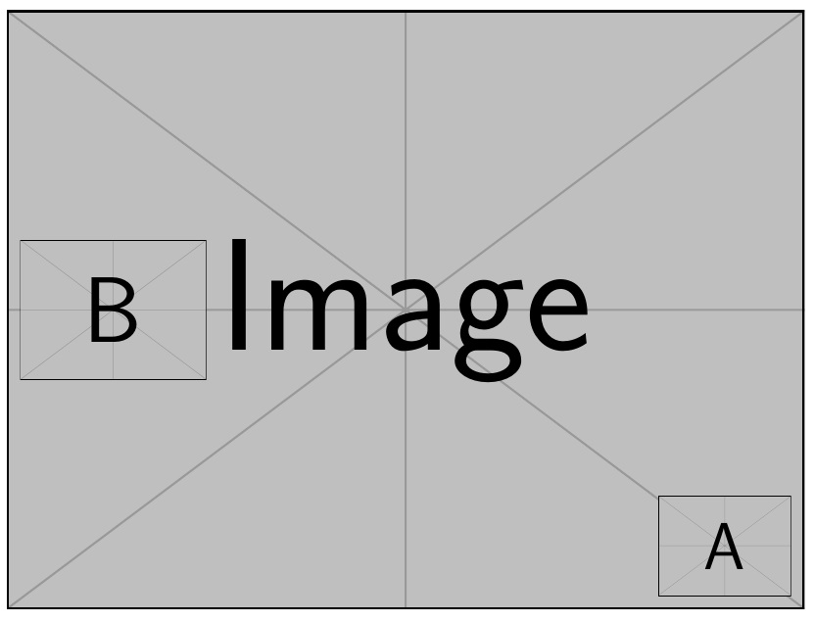

Figure 1: Above is….

4. Discussion & Conclusion: Primary header style (Heading 1)
Traditionally the discussion and conclusion is where the researcher interprets the results, places them in context, and wraps everything up for the reader, highlighting notable findings and proposing future research. The reader should be able to link what was included in the preceding sections with what is presented in the conclusion.

Acknowledgments: Primary header style (Heading 1)
Acknowledge funding and others when appropriate.

References: Primary header style (Heading 1)
Please refer to APA guidelines for the use of references and citations. Citations should follow the author, year format, e.g., (Cook & Corbett, 2020).

Cook, S., & Corbett, J. (2020). Understanding gendered geographies of street homelessness using participatory mapping. Geomatica, 73(4), 81-92.

